Task on S3 – Bucket

- Create an S3 bucket and upload some objects to S3.
Go to AWS Console → S3 → Create bucket
Enter a unique Bucket name
Choose Region
Keep default settings → Click Create bucket
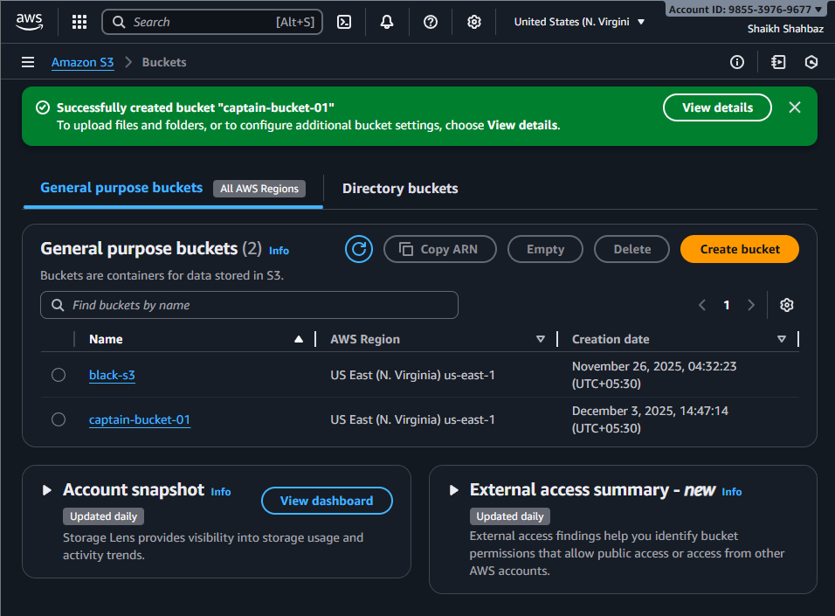
I have created a bucket with bucket name <captain-bucket-01>

Upload objects
Open your bucket
Click Upload
Add files → Click Upload

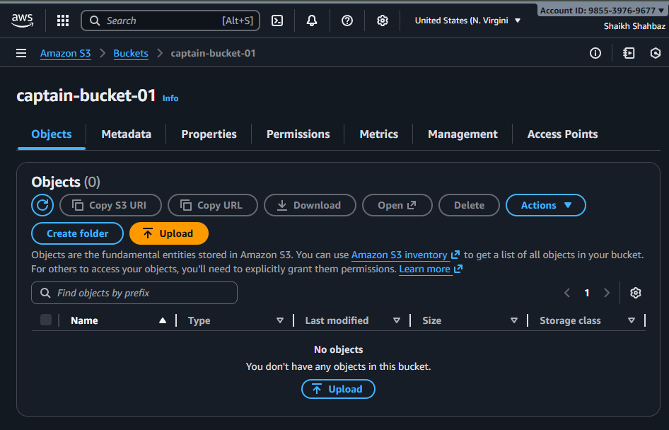
Here we can add the files to the s3-bucket.
Click on upload Add files then choose file to add in s3-bucket then click upload
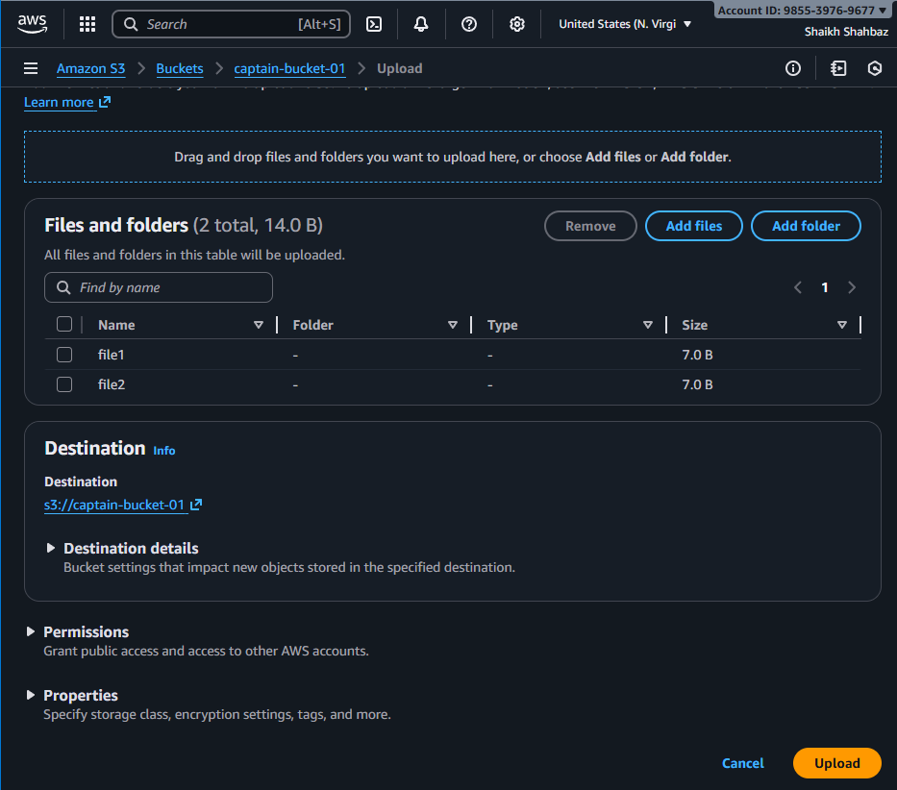
file1 and file2 is uploaded to s3-bucket
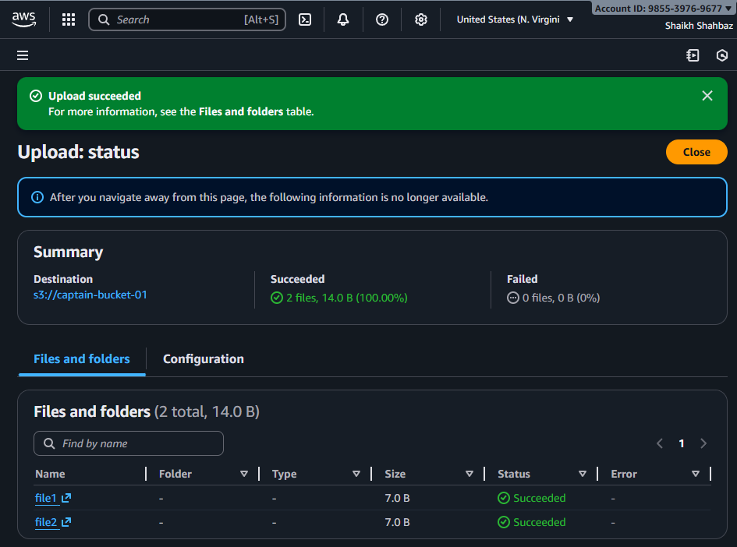

- Deploy a static website in the S3 bucket.
Step 1: Enable static website hosting
Go to your S3 bucket → Properties
Scroll to Static website hosting
Enable
Select Host a static website
Provide:
    - index.html
    - error.html
Click Save
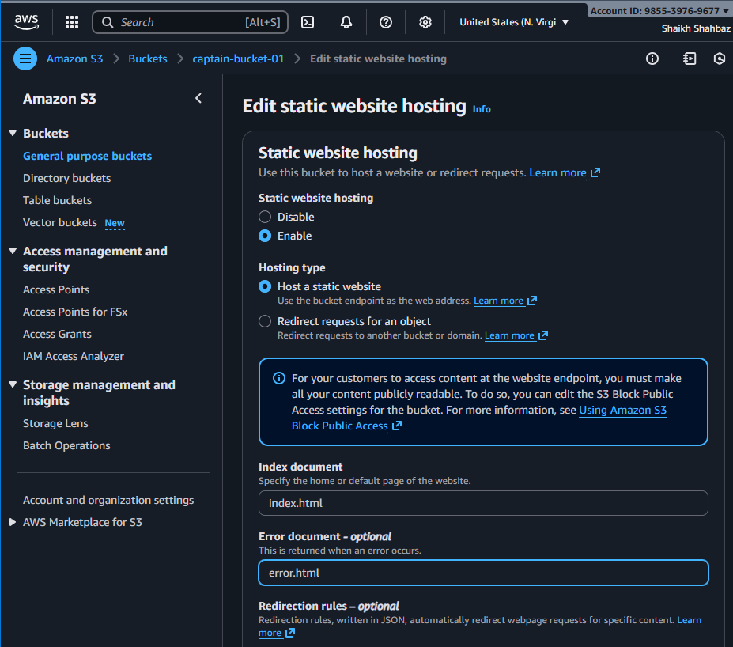

Step 2: Upload your website files
Upload index.html, style.css, images, etc.
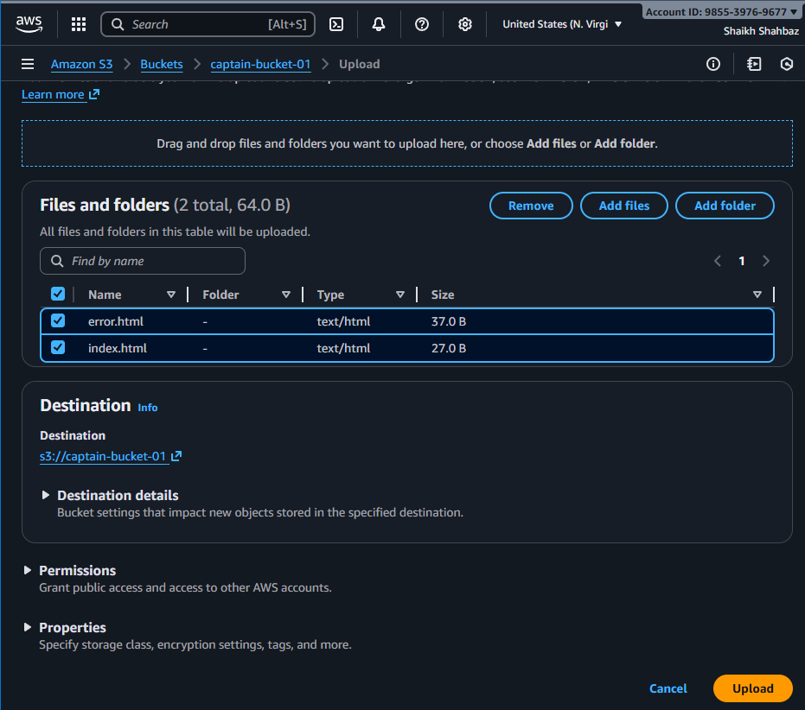
Step 3: Make content public
Go to Permissions → Bucket policy, add:
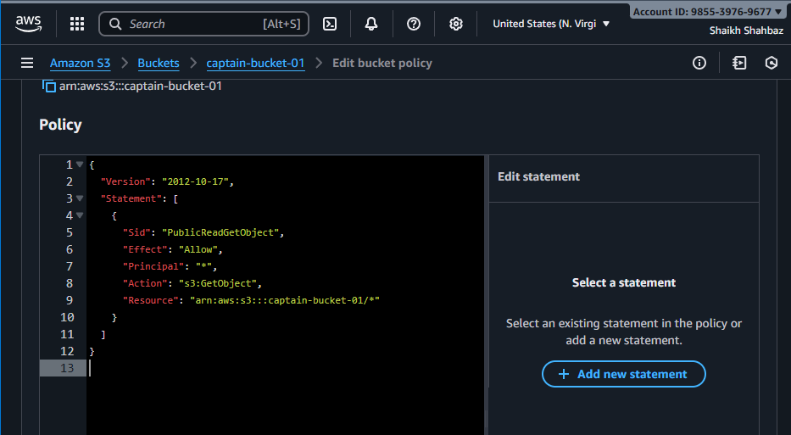
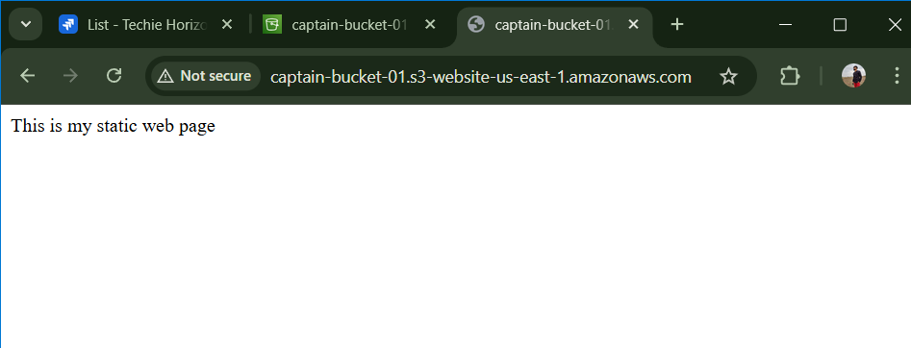
This is my static webpage
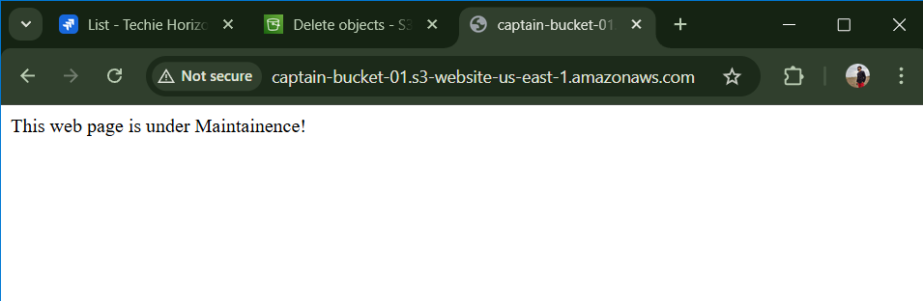
This is my static webpage when there is any issue at index.html file

- Enable cross-region replication on S3 buckets.
Prerequisites
Versioning must be enabled on source and destination buckets.
Destination bucket must be in a different region.
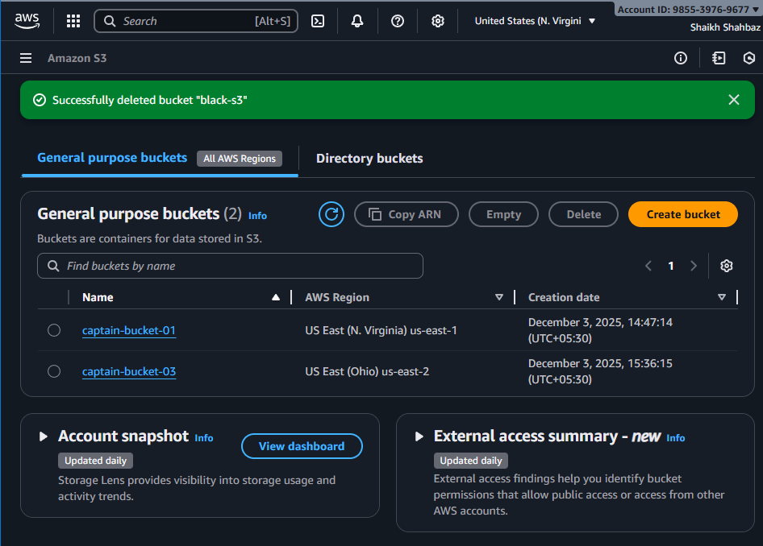
One bucket is in <N.Virginia region> and other bucket is in <Ohio region>
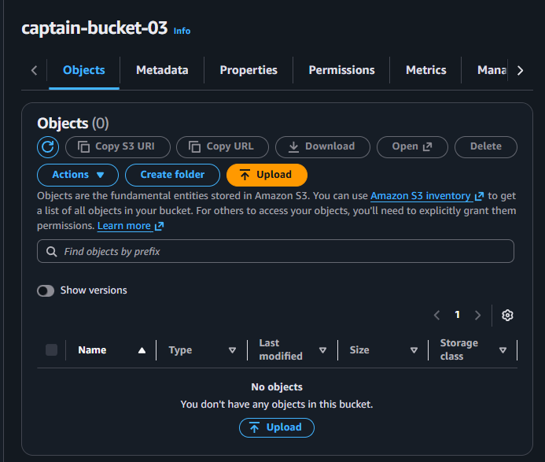

Steps
Go to Source bucket → Management
Click Replication → Create replication rule

Source bucket name <captain-bucket-01>
Destination bucket name <captain-bucket-03>
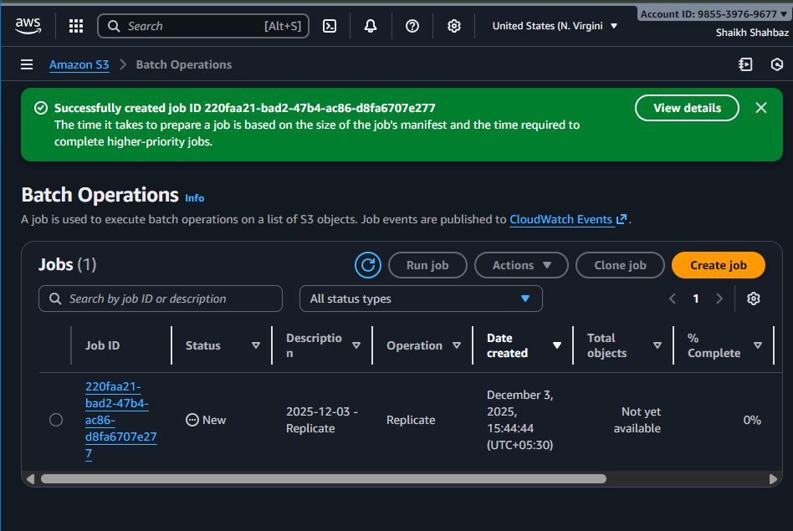

Configure:
Choose prefix or entire bucket
Select Destination bucket
Enable IAM role auto-create
Save rule
Now objects automatically replicate to the destination bucket.
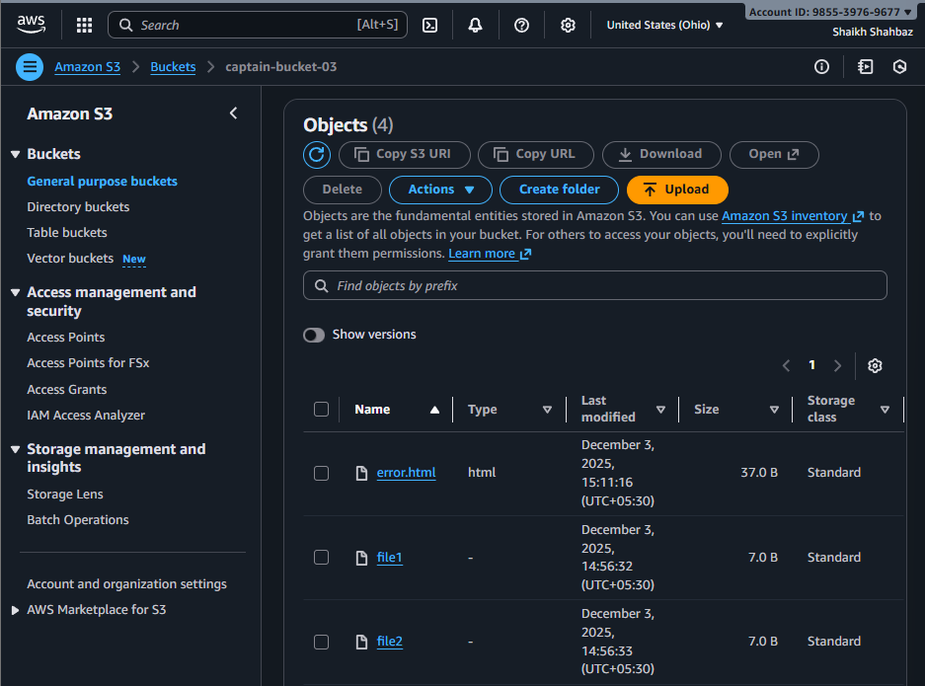

- Configure a bucket policy so only the Admin user can see the objects of the S3 bucket.
Make the s3 bucket private
Allow access to only one specific IAM user (Admin)
Objects should be visible only to that Admin user
Step 1 :
Goto IAM Users Admin User ARN
Then copy ARN id
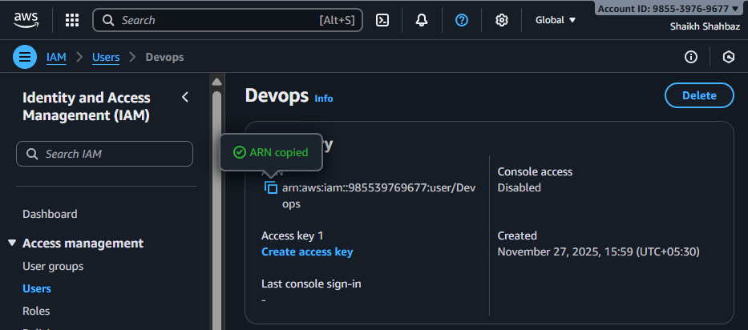
Step 2 :
Go to s3 Your bucket Permissions Block Public Access
keep everything ON
bucket remains private
no public access allowed
only Admin user will have permission
Step 3 : Add bucket policy allowing only admin user
Go to s3 Bucket Permissions Bucket Policy
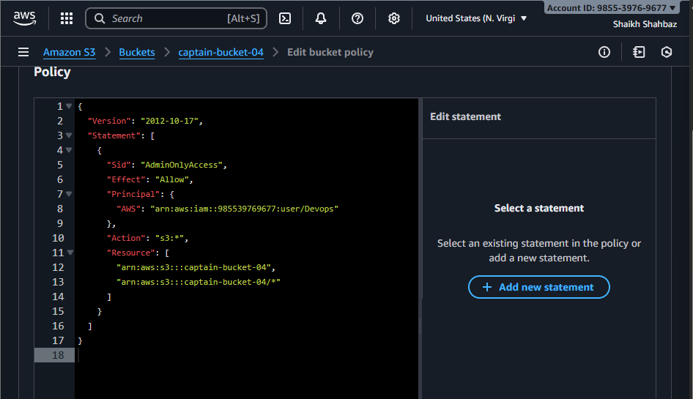
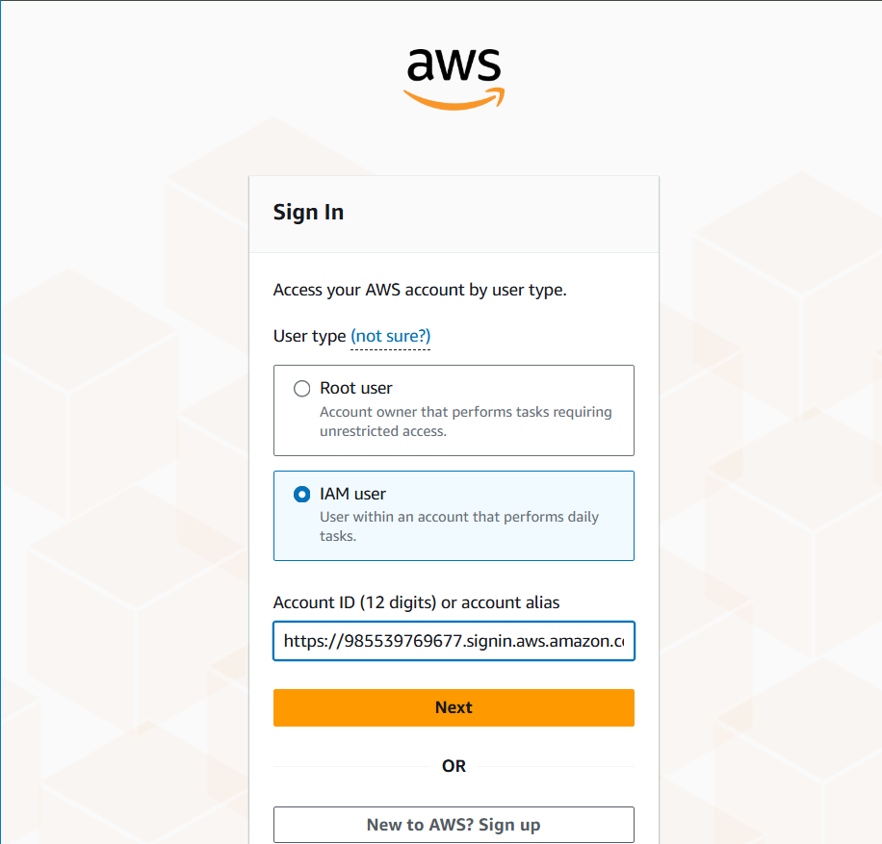
Now this bucket will only accessed by the <Devops-user> only and it is restrivted to any other user except the user we have provided in bucket policy
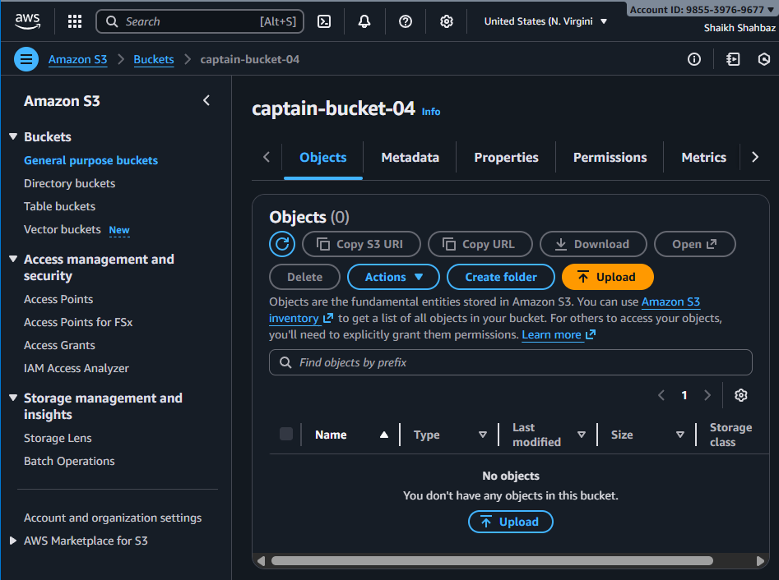

- Set up lifecycle policies to automatically transition or delete objects based on specific criteria.
Example lifecycle rule:
Transition objects to Glacier after 30 days
Delete after 365 days
Steps
Go to your S3 bucket → Management
Click Lifecycle rules → Create rule
Add transitions:
-After 60 days → Glacier Flexible Retrieval
Save

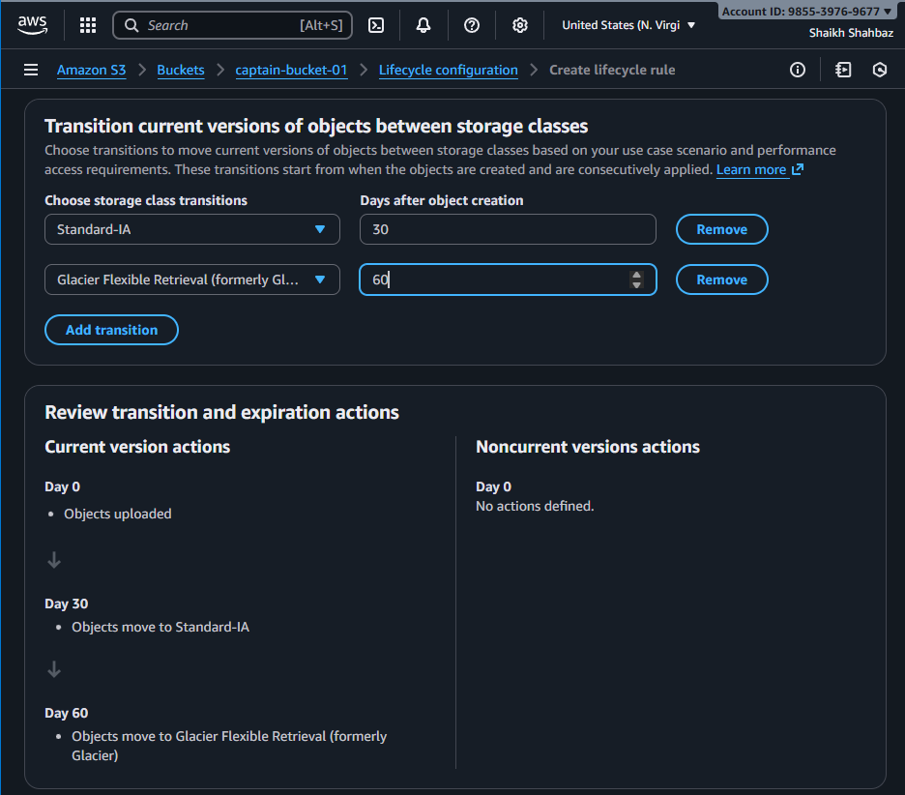
The Objects will be deleted or moved to archive based upon its class
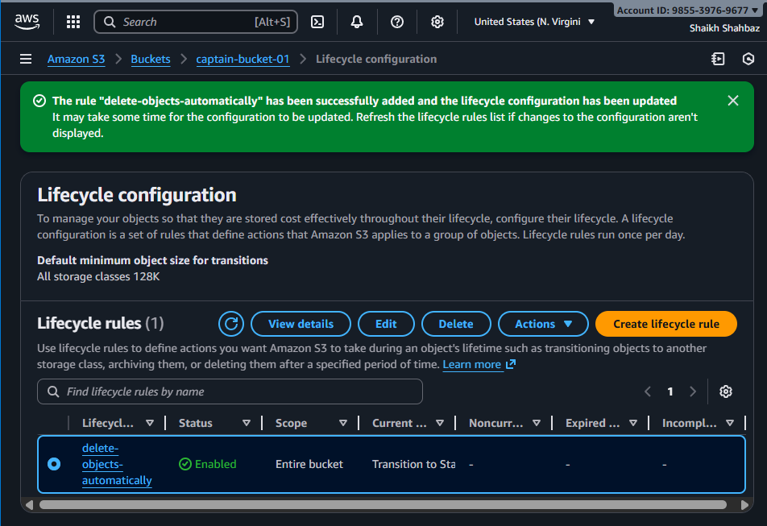

- Push some objects to S3 using the AWS CLI.
I have one empty bucket <captain-bucket-04>
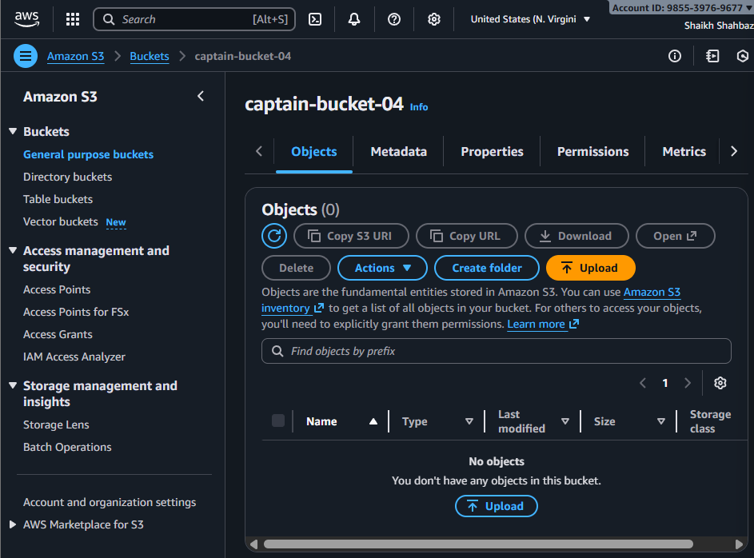
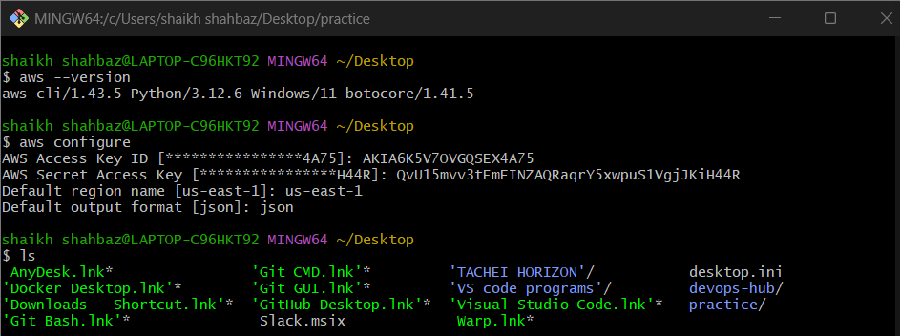
After configuring the aws account in cli now we will upload files and folders to the s3 bucket from cli
To upload one file at a time we use command
aws s3 cp <file-name> s3://<bucket-name>
To upload multiple files to the s3 bucket we use command
To upload all <.jpg> files
aws s3 cp . s3://<bucket-name> --recursive --exclude "*" --include "*.jpg"
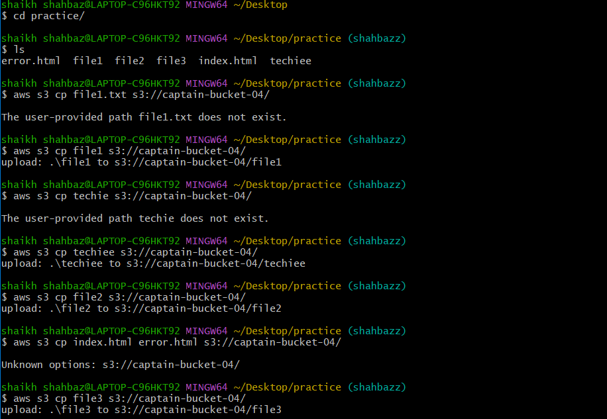

Here we can see that from cli interface I have uploaded the files to the s3 bucket
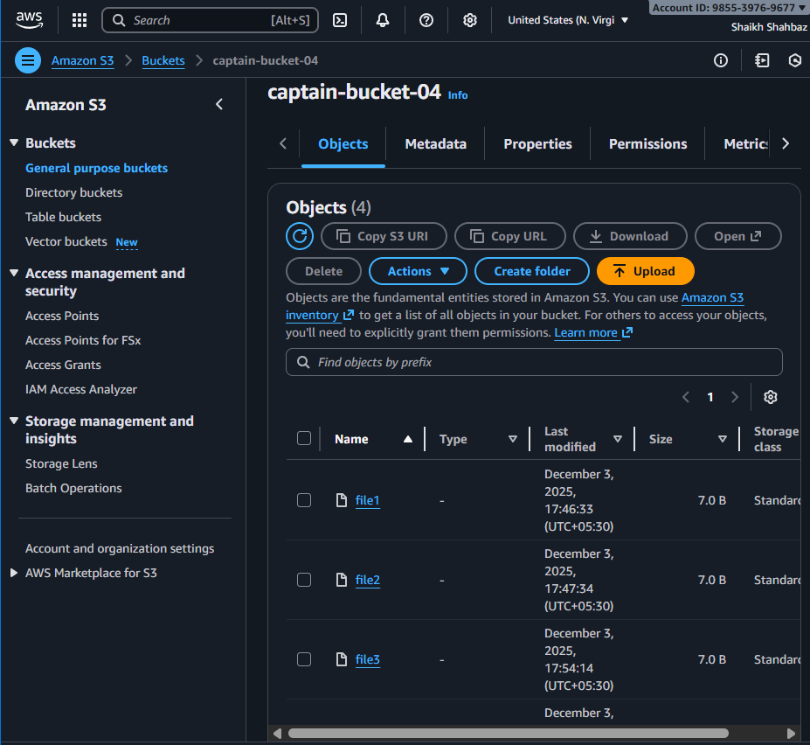

- Write a Bash script to create an S3 bucket.
First create one file to save the script
vi <script-name.bash>
vi create-bucket.bash
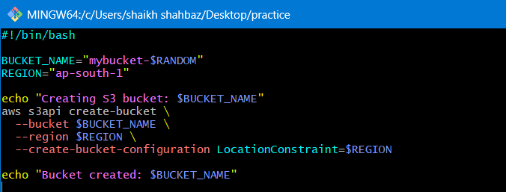
chmod 755 create-bucket.bash
./create-bucket.bash
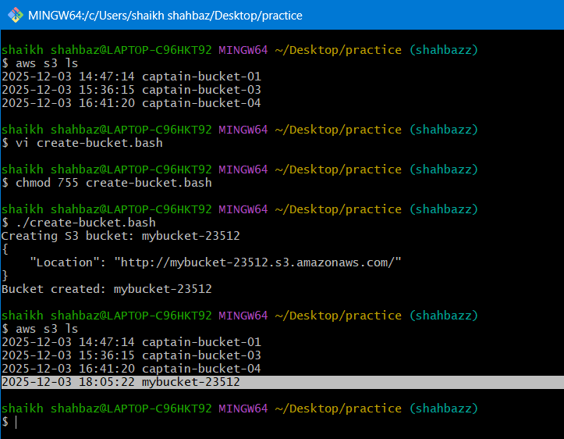
Here we can see that the bucket with <mybucket-23512> name is created
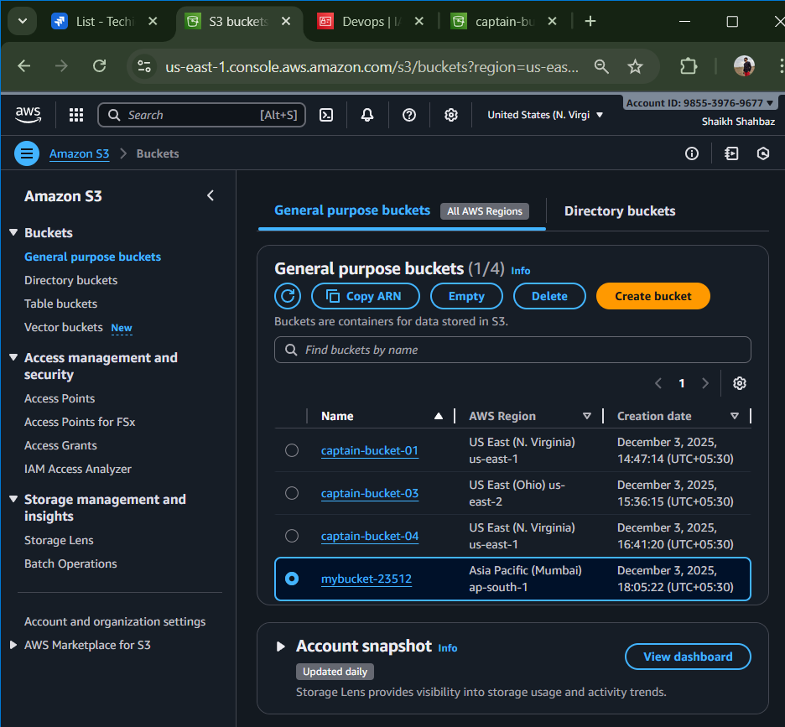

- Upload a 1 GB file to S3 using the CLI
your AWS CLI skills
your understanding of uploading large files
ability to create test data and push to S3

I have one folder named as <practice> and I want to upload this folder to the s3-bucket named as <captain-bucket-04>
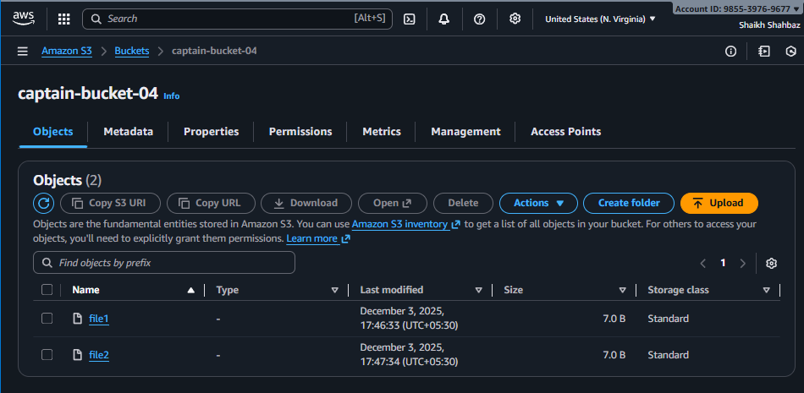
This is before uploading a 1 gb file
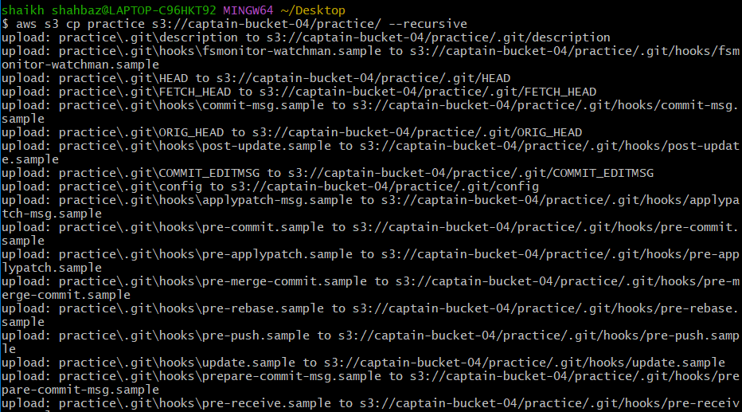

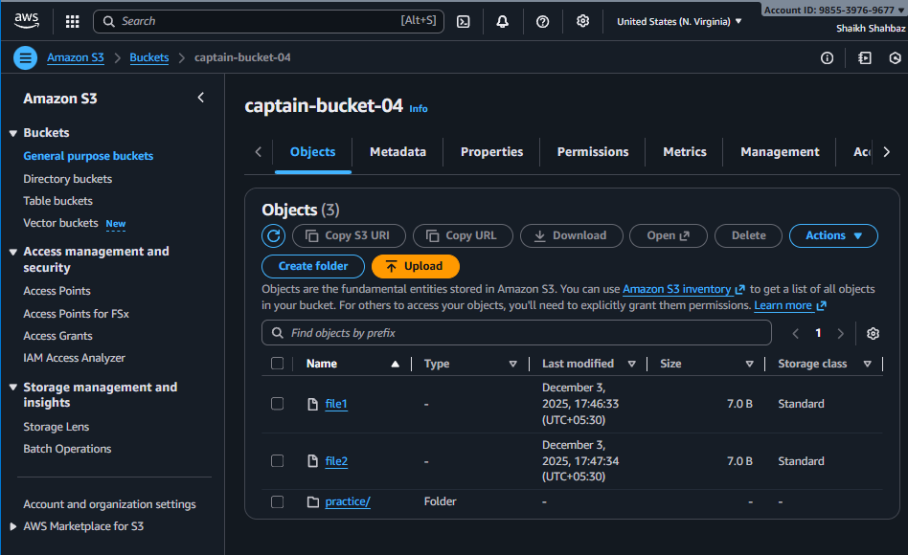
In practice folder we have these many files
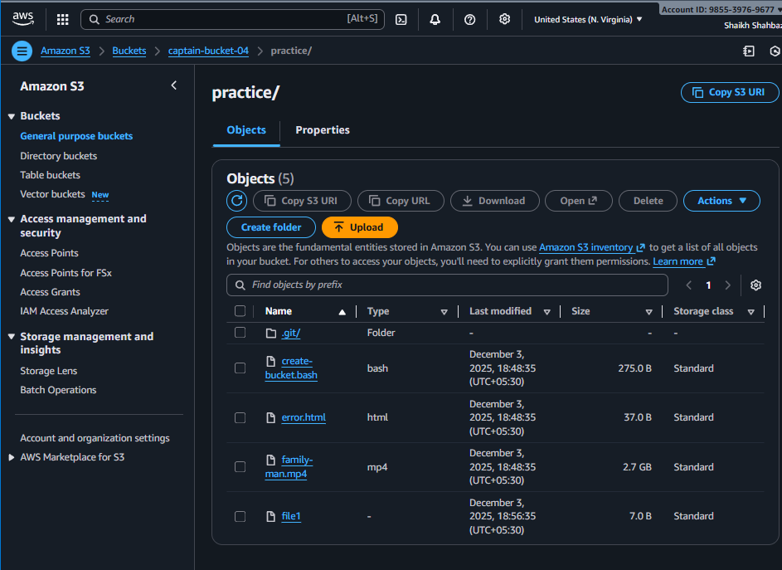

This is Another method to perform 8th task
First we need to create 1 gb file and upload it to the s3 bucket through cli only

Create a 1 GB File
dd if=/dev/zero of=file1gb.bin bs=1M count=1024

if=/dev/zero → input file is zeros
of=file1gb.bin → output file name
bs=1M → block size = 1 MB
count=1024 → 1 MB * 1024 = 1024 MB = 1 GB

Upload the 1 GB File to S3-bucket
aws s3 cp file1gb.bin s3://captain-bucket-04/

Verify the Upload
aws s3 ls s3://captain-bucket-04/
